Example Workplan Purpose and Instructions
The Environmental Finance Center at California State University, Sacramento (EFC at Sacramento State) is working with EPA Region 9 to provide cost-free technical assistance to Community Grant recipients in preparing their grant applications. The EFC developed this example workplan to aid recipients in preparing two required components (the project narrative and the budget narrative) of the application package.
This workplan includes an example project narrative, budget narrative, and other elements needed by EPA to process applications and execute funding agreements and is applicable to congressionally delegated projects with funding appropriated in fiscal years 2022 through 2026.
The workplan is organized into the following sections:
- Executive Summary
- Introduction (Section 1)
- Project Objective and Need (Section 2)
- Project Description (Section 3)
- Budget Narrative (Section 4)
- Milestone Schedule (Section 5)
- Environmental Results/Benefits (Section 6)
- Requirements for Identifying Contractors (Section 7)
- Requirements for Obtaining Subrecipients (Section 8)
This document provides example text and descriptions of the information that should be included in each section of the workplan to guide the author in completing a workplan that will fulfill the Community Grant application requirements. The text highlighted in cyan, yellow, and grey provide the following:
Cyan: Indicates instructions that reflect specific requirements from the Community Grants Program Final Implementation Guidance 2024 and information helpful to EPA project officers in processing applications and executing funding agreements.
Yellow: Indicates placeholder text that should be replaced with project-specific information.
Grey: Indicates suggested example language that reflects the requirements from the Community Grants Program Final Implementation Guidance 20241 and may be kept in the workplan or replaced with project-specific details.
Plain/unhighlighted text provides the narrative for the “example” fictitious Washington Water District Project and should be replaced with recipient’s project-specific narrative.
Once completed, the applicant’s workplan can be uploaded as a pdf attachment to both the project narrative and budget narrative fields in the application package on Grants.gov. For additional information or questions regarding this example workplan, please contact EFC@CSUS.edu.

COMMUNITY GRANTs WORKPLAN

WasHINGTON WATER DISTRICT

Washington Avenue Water Reliability Improvement Project

Key Personnel

<Name#1, Title>

Washington Water District

<Email>

<Phone#>

<Name#2, Title>

Washington Water District

<Email>

<Phone#>

<Name#3, Title>

Washington Water District

<Email>

<Phone#>

<November 2025>
EXECUTIVE SUMMARY
<Include an executive summary (two-three paragraphs at most) that summarizes the information listed below. For ease and consistency, complete the work plan first, and then cut and paste information from the appropriate sections.
- Project Purpose, Description, and Intended Beneficiaries (copy and paste from Sections 2.0 and 3.0)
- Main Activities/Tasks (copy and paste from Section 3.2 and include project start and end dates from Section 5.0)
- Project budget and Cost Share Match (copy and paste from Section 4.0)
- Anticipated Outputs that will be submitted to EPA (copy and paste from Section 6.1)
- Anticipated Outcomes (summarize, copy and paste from Section 6.2)>
The Washington Water District Reliability Improvement Project will design and construct a new water main and install fire hydrants to meet current demands within the District’s Washington Avenue service area, which serves a population of approximately 32,600 residents (the intended beneficiaries). The existing water main was built in the mid-1900’s, has deteriorated, leaks extensively, is undersized, and no longer provides adequate water supply for consumption and fire protection for the community. The district intends to procure an engineering consultant to design and plan implementation the new water main and fire hydrant system and procure a construction contractor to install system. The project is anticipated to start on January 1, 2025, and will be completed by October 31, 2026. The anticipated budget for the project is $3,750,000, of which $3,000,000 will be funded with the grant award and $750,000 is the cost share match, which will come from the water district revenues.
The project deliverables/outputs to be submitted to EPA include:
- RFP/Bid Packages Prior to Release for EPA Review
- Consultant and Construction Contracts for EPA Review prior to Final Agreement
- 100% Design Plans and Specifications
- SWPPP
- As-built drawings
- A Post-construction On-site Project Review by EPA (or delegate)
- Quarterly Progress Reports
- A Draft and Final Project Report
The anticipated benefits/outcomes include:
- Increased water available for consumption (estimated 1MG/year) as a result of reduced water wasted from leakage.
- Increased customer satisfaction as realized by a 30% decrease in customer complaints.
- Reduced District staff time (approximately 20 hours per month) spent responding to infrastructure failures.
- Reduced energy consumption (approximately 10 MW/year) due to more efficient water delivery.

The project will protect the environment by reducing waste and providing adequate fire protection, providing additional safe drinking water, and more reliable infrastructure that meets the current community needs.

INtroduction
The Washington Water District (District) has been awarded Fiscal Year (FY) 2023 funding through the Environmental Protection Agency’s (EPA’s) Community Grants program. The program provides a valuable source of federal funding for water infrastructure. The funding awarded to the District is intended for replacing an old and undersized water main within the District service area, along with installation of fire hydrants to improve fire flow.
This workplan serves as the project narrative and budget narrative, which are required attachments for Community Grants Program application. The remainder of this workplan includes the following information:
- Project Objective and Need (Section 2)
- Project Description (Section 3)
- Budget Narrative (Section 4)
- Milestone Schedule (Section 5)
- Environmental Results/Benefits (Section 6)
- Requirements for Identifying Contractors (Section 7)
- Requirements for Obtaining Subrecipients (Section 8)

Project Objective AND NEED
<Clearly describe the objective, need, and intended recipients (beneficiaries) of the project. Provide pertinent background information and details and include attachments if needed. If the project to be funded by the Community Grants is part of a larger project effort, a brief description of the overall effort can be included to provide background and perspective. However, the Scope of Work that follows should focus only on the portion of the project that will be funded specifically by Community Grant funds.>
The objective of this project is to design and construct a new water main and install fire hydrants within the District’s Washington Avenue service area. Having been built in the mid 1900’s, the existing water main has deteriorated over time and is subject to extensive leakage. The existing main is also undersized, and, combined with the leakage, no longer provides adequate supply for the community in the area. A new, larger main needs to be installed, along with fire hydrants, to meet current demands and provide adequate flow for fire protection.

PROJECT DESCRIPTION
The project location and scope of work are described below.
< Clearly define the following: scope of work, outlining all activities to be performed under the grant; detailed description of the proposed project with a summary of key milestones and deliverables; framework for managing the project with an explanation of the approach, procedures, and controls for ensuring that awarded grant funds will be expended in a timely and efficient manner; explanation of how performance will be evaluated and reported highlighting progress toward achieving the expected outputs and outcomes. The scope of work should conform with the project description for which the funds were allocated. The description should include narrative, maps, figures, relevant design parameters, etc.>

Project Location
The District is located in the Town of Washington in Sacramento County, CA (Figure 1) and serves a population of approximately 32,600. A general map of the project site – the District’s Washington Avenue service area – is shown in Figure 2.
Figure 1. Project Location
<Insert project location map, which should show the state and vicinity (i.e., city, town, community) where the project is located within the state.>
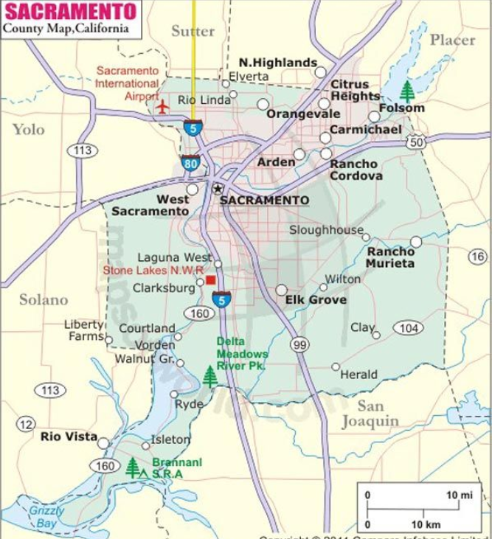
Town of Washington
Figure 2. Site Map
<Insert the site map, which should show the project location, project features, and details. >
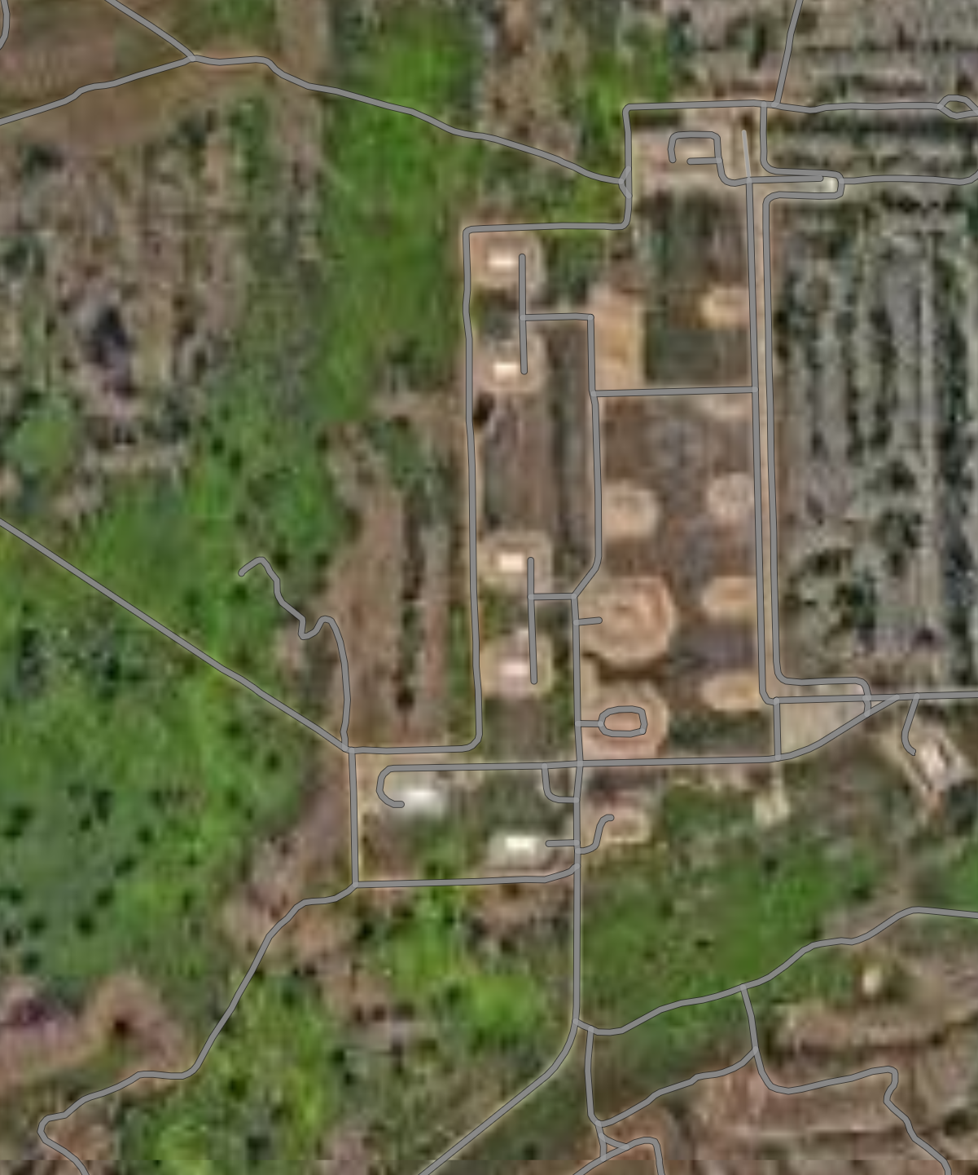
Town of Washington, California
Upgraded Water Line

Project Location
New Hydrant Location

Scope of Work
<Clearly define the scope of work, outlining all activities to be performed under the grant. Recipient should choose how best to separate/organize the project into tasks to simplify future reporting. The task breakout below is provided as an example. It may be easiest to breakout tasks based on how funds (i.e., grant funds verses cost match funds) will be used or by major project task/milestones such as environmental review, design phase, construction phase, and overall project management.
<Please note as required by EPA’s National Environmental Policy Act (NEPA) implementing regulations (40 CFR 6.100-6.406), EPA must complete the NEPA review process before awarding a grant for design and/or construction. The requirement for an environmental review under NEPA generally does not apply to grants solely for planning activities, such as infrastructure assessments, watershed plans, and capital improvement plans. For these cases, a Categorical Exclusion (CATEX) needs to be completed prior to grant award.>
The project includes the design and construction of a new water main and installation of fire hydrants within the District’s Washington Avenue service area. The project will be divided into the following tasks:
- Task 1 - Planning and Design
- Task 2 - Construction and Implementation
- Task 3 - Project Management and Controls

Task 1 - Planning and Design
This task will include planning and design activities necessary to complete a 100% design package, environmental reviews and documentation, and other preparations for construction activities and required compliance.
Planning activities will include soliciting bids and selecting a contractor for development of final design drawings and specifications, obtaining environmental permits, obtaining relevant approvals, coordinating construction staging, traffic routing, waste disposal, etc., and managing the design contract. Engineering and design services will be conducted through an engineering and design contract. The project team will develop an Invitation for Bid package that consists of the requested scope of work, figures, schedules, and general contractual duties for planning and designing the project. An engineering consultant will be obtained in accordance with EPA Community Grant requirements, as described in Section 7 of this work plan. Upon award of the design contract, the District will provide oversight of the final design and engineering specifications, including surveying of existing conditions.
Development of a Stormwater Pollution Prevention Plan (SWPPP) in accordance with the California 2022 Construction Stormwater General Permit is required for the construction phase of the project and will be incorporated into the design plans and specifications. (The SWPPP will be developed under Task 2).
<Include any needs related to right of way acquisitions, necessary permits, or regulatory compliance. The previous paragraph refers to the California 2022 Construction General Permit. Requirements will vary depending on project type, size, and location. Applicants should refer to their state-specific CGP requirements. EPA will want to review any RFPs prior to release or consultant contracts prior to award. >
Specific outputs/deliverables for this task are listed in Section 5, Table 3. The District will report progress and completion of milestones and deliverables in quarterly progress reports submitted to EPA (see Task 3).

Task 2 - Construction and Implementation
This task will include administration of the construction contract, labor compliance, construction management, environmental compliance, and actual construction and implementation of the proposed infrastructure.
Contracting will require development and solicitation of an Invitation for Bid package and selection and oversight of a construction contractor. Contractors will be obtained in accordance with EPA Community Grant Program requirements, as described in Section 7 of this work plan. A Construction Manager (CM) will be assigned to oversee construction activities to ensure compliance with the applicable city, state, and federal contract requirements, including labor compliance and implementation of all necessary environmental protections. The CM will also ensure implementation of traffic controls and coordinate and approve any necessary field design modifications. Such oversight will require, at a minimum, weekly conference calls and/or construction site visits, along with daily field notes and red-line construction drawings. The CM will work with and report directly to the District to keep them informed of project progress.
Actual construction activities will include project staging, surface and infrastructure preparation, excavation, existing main removal, and installation of the new main and hydrants installation, and regarding. <Expand on these details as appropriate.>

Upon completion of construction, the project team will coordinate with EPA to conduct an on-site project review and confirm successful implementation.

Specific outputs/ deliverables for this task are listed in Section 5, Table 3 Progress and completion of these deliverables will be documented in quarterly project reports submitted to EPA (see Task 3).

Task 3 - Project Management & Controls
The District will manage the project activities and implement controls to ensure that the project is executed according to the agreed-upon scope, schedule, and budget, and that all mandated procedures, including reporting, are followed. The primary project management activities will include conducting a kickoff meeting, developing quarterly progress reports, submitting project reports and summaries, providing final project inspection and certification, attending conference calls, coordinating task efforts, and tracking task progress and budget.
The District will submit quarterly progress reports to EPA documenting activities completed during the quarter and the status of major milestones. Section 5.0 of this work plan presents project milestones.

Budget Narrative
<The budget narrative links the budget to workplan task activities and includes source(s)of federal funding (grant allocation) and of non-federal cost share match funds (if required). The total project budget should include the grant allocation and any minimum required cost share match. It is recommended that an overmatch not be included as any overmatch included would be subject to federal spending requirements. The cost breakdown included in this section should correspond to the information included in the SF-424A form, which is a required form in the application.
Also, while it is important to keep this workplan focused on the EPA-funded project, if the project is part of a larger effort, please describe any other funding sources that may be applied to the overall larger effort described in Section 2. For example, the EPA Community Grant may only be funding a smaller project that fits within a larger project or regional effort. If so, please describe any other funding sources (federal, state, local) that will be used to fund the overall project or larger regional effort.>
The total estimated budget for this project is $3,750,000, of which $3,000,000 is the Community Grant allocation and $750,000,000 is the minimum required cost share match, which will come from District revenues. Table 1 presents project costs categorized by task. Table 2 lists the full costs for the proposed project and is followed by a narrative description of how figures for each budget category were determined.
Table 1. Project Costs by Task
<Tasks listed in this table should correspond to the tasks identified in Section 3.2 Scope of Work.>
Task | Dollar Amount
Task 1, Planning and Design | $1,000,000
Task 2, Construction and Implementation | $2,500,000
Task 3, Project Management and Controls | $250,000
TOTAL | $3,750,000

Table 2. Budget breakdown by EPA Object Class Category
<These categories correspond to those listed on the SF-424A form required with the grant application. Authors should include their project-specific dollar amounts and include additional details for each budget category after the table. >
Budget Category | Dollar Amount
Personnel | $230,000
Fringe Benefits | $10,000
Travel | $10,000
Equipment | $X (include “0” if no costs in this category)
Supplies | $X (include “0” if no costs in this category)
Contractual | $1,000,000
Construction | $2,000,000
Other Direct Costs | $X (include “0” if no costs in this category)
Indirect Costs | $X (include “0” if no costs in this category)
TOTAL | $3,750,000

Personnel ($230,000): Costs include labor salary for a District project manager and District project support staff to implement activities outlined in this work plan and otherwise manage the grant. <Please note costs for personnel should be broken down into estimates of the position, cost for that position’s time, and amount of time to be spent. For example: Senior Engineer; $80 per hour; 100 hours. If no personnel costs are applicable to this project, this section should be replaced with the following statement: “No reimbursement for staff labor, including salaries is requested.”>
- Project Manager: <Name, Title> will primarily oversee the successful execution of all project activities and deliverables, including high-level planning, implementation, and overall reporting. The PI will also coordinate project- related support activities between key city departments and manage collaborations with the leadership of project partners.
- Project Support Staff: At least X additional project staff will be needed to support the Project Manager with the planning and delivery of the proposed tasks and activities. Such staff may be employed to assist with <include description of tasks>.
Fringe Benefits ($10,000): Costs include benefits and accruals. <Describe assumptions, e.g., a percentage of personnel. If no costs are applicable to this project, this section should be replaced with the following statement: “No reimbursement for staff labor, including benefits and accruals, is requested.”>
Travel ($10,000): Costs cover projected travel for X District staff to attend weekly on-site meetings during construction. <describe where and why>. The costs cover lodging, airfare, vehicle rental, and per diem for X days. <If no travel costs are applicable to this project, this section should be replaced with the following statement: “No reimbursement for travel is requested.”>
Equipment ($0): “No reimbursement for project equipment is requested.” <If equipment costs are applicable, describe equipment to be acquired by the recipient (not contractor/consultant), why, and relevant costs.
Supplies ($0): “No reimbursement for project supplies is requested.”<If supply costs are applicable, describe supplies to be acquired by the recipient (not contractor/consultant), why, and relevant costs; or replace.
Contractual Services ($1,000,000): Costs associated with Task 1- Design and Planning and described in Section 3.2 will be included under contractual services. A detailed budget breakdown of the scope and activities for Task 1 are included in Attachment A to this document. <Describe services, types of costs and amounts for consultants and design/planning-related contractors and include backup documentation as an attachment if available. Design contracts, environmental review contracts, and other contracts related to the non-construction planning and design phase of the project should be included in “contractual.” Any contract that involves construction should be included in the “construction” category. If no contractual services are applicable to this project, this section should be replaced with the following statement: “No reimbursement of contractual services is requested.”>
Construction ($2,000,000): Costs associated with Task 2 – Construction and Implementation and described in Section 3.2 will be included under Construction. A detailed budget breakdown of the scope and activities for Task 2 is included as Attachment A to this document. <Any contract that involves construction or materials, equipment, or supplies related to construction should be included in the “construction” category. Describe construction costs covering project-related construction and include backup documentation as an attachment if available. If no construction costs are applicable to this project, this section should be replaced with the following statement: “No reimbursement of construction costs is requested.”>
Other Direct Costs ($0): No reimbursement for other direct costs is requested. <Describe other direct costs not covered in any of the above categories.>
Total Direct Costs Subtotal ($3,750,000): The total direct costs for this project are $3,750,000. <Add up all total direct costs above and include the sum total here.>
Indirect Costs ($0): No reimbursement of indirect costs is requested. <Describe assumption, referencing relevant indirect rate agreements or otherwise. If the project has indirect charges, the applicant will need to submit a Negotiated Indirect Cost Agreement if one exists. Or applicants will need to use the federal de minimus rate, if such indirect costs are allowable.>

Total Costs ($3,750,000): Includes $3,750,000 for total direct costs, $0 for indirect costs. <Add up all total direct and indirect costs above and include sum total here.>
Cost Share ($750,000): <If the grant recipient has received a cost share waiver, please indicate: “EPA has granted a cost share waiver for this project.” If not, describe the sources of matching funds. Eligible sources of cost share funds are described in the Community Grants Program Final Implementation Guidance 2024. Divide these out by source – that is matching funds that you are bringing to the table on your own as an applicant or State and other sources. For all three of these categories, include both case and in-kind match amounts. Provide specifics as this information will also be included in the SF-424A Form.>
Pre-award Costs ($0): There are no pre-award costs included in the budget. <Describe any pre-award costs that the recipient may request reimbursement for. If the community is not including pre-award cost, please indicate “The <City/Community>has not included pre-award cost.”>
<Costs incurred prior to grant awards may be eligible for reimbursement if the costs are in conformance with applicable federal and EPA statutes and regulations. Incurred costs are financial obligations: costs owed by an entity as a result of a transaction. The costs may have been paid or remain unpaid. The EPA has specific requirements for the reimbursement of Pre-award Costs. Pre-award costs are project costs incurred prior to the grant award that the recipient will be seeking reimbursement for. It is highly recommended that any recipient that plans to request reimbursement for pre-award costs meet with their assigned EPA Project Officer to discuss the pre-award cost review process. Ideally, this meeting should occur prior to completion of the workplan as it may result in a change in approach or project objectives. There are also limitations on how far back EPA will consider pre-award costs. Please refer to the Grant Implementation Guidance document that corresponds to the fiscal year in which your congressional delegated allocation was received (i.e., FY22, FY23, FY24, etc.).>

Other Funding Sources
No other sources of funding will be used on the project.
<Describe all other sources of funding (federal, state, local, private, etc.) that will be used to fund the overall project. For example, the EPA Community Grant may only be funding a portion of a larger project. Please describe any other funding sources (federal, state, local) that will be used to fund the larger overall project described in Sections 2 and 3.>

MILESTONE SCHEDULE
<Include a narrative and tabular depiction of each activity’s estimated start and end dates, interim milestones, deliverables, and project completion. The length of the grant award project period should be consistent with the milestone schedule and included on form SF-424, which is required with the application. Please include contingencies for project delays and describe any assumptions/conditions that may impact the project schedule. Recipients may have up to 5 years for the initial period of performance. After that time, an extension may be requested but may not be guaranteed to be granted. If pre-award costs are anticipated, please include these tasks and timeframe in the project schedule.>
The project is scheduled to begin on January 1, 2025, and be completed by October 31, 2026. This assumes that the grant will be awarded no later than October 31, 2024, and long-lead construction materials are obtained no later than July 1, 2026. Contingencies for project delays have been included in the schedule. Table 3 presents the project schedule, major milestones, and deliverables.

Table 3. Project Schedule and Milestones <Update table with project-specific schedule, tasks, milestones, and deliverables. Include extra notes as appropriate.>
Task/Milestone | 2025 |  |  |  | 2026
Task/Milestone | Jan-March | April -June | July- Sept | Oct- Dec | Jan-March | April -June | July- Sept | Oct- Dec
Estimated Start Date: January 1, 2025
Task 1, Planning & Design
- Permitting/design RFP¹ | X
- Permitting/design contracts executed¹ |  | X
- 60% design plans and specifications completed |  |  | X
- 100% design plans and specifications¹ |  |  |  | X
- Bid package¹ |  |  |  | X
Task 2, Construction
- Construction RFP ¹ |  |  |  |  | X
- Construction contract executed¹ |  |  |  |  |  | X
- SWPPP submittal² |  |  |  |  |  | X
- Construction |  |  |  |  |  | X | X | X
- As-built Drawings¹ |  |  |  |  |  |  |  | X
- EPA on-site review completed¹ |  |  |  |  |  |  |  | X
Task 3, Project Management and Controls
- Quarterly project reports¹ | X | X | X | X | X | X | X
- Draft and final project report¹ |  |  |  |  |  |  |  | X
Estimated End Date: October 31, 2026
¹ These items are the work products/outputs that will be submitted to EPA for review.
² SWPPP, if required by project, will be reviewed by the EPA Project Officer upon submittal. <Confirm with project-specific EPA PO if they prefer to review the SWPPP as a required deliverable.>

ENVIRONMENTAL RESULTS/BENEFITS
One goal of the Community Grants program is to ensure safe drinking water and reliable water infrastructure. The section describes how the project supports that goal and further describes the environmental outputs and outcomes for the project.
Table 4 summarizes how the various project activities will contribute to this goal and objective.
Table 4. How Project Activities Ensure Safe Drinking Water and Reliable Water Infrastructure
<Update the table based on project-specific tasks and goals.>
Task | Contribution
Task1 - Planning and Design | Results in 100% design plans for installing new water main and hydrants to improve water supply, including fire flow, to community members.
Task 2 – Construction | Results in installation of new water main and hydrants to improve water supply, including fire flow, to community members.
Task 3 - Project Management and Controls | Supports effective and efficient use of funds for a sustainable end product.

Anticipated Outputs
<Outputs are the direct products or activities of the project related to environmental goals or objectives that will be produced of provided over a period of time or by a specified date. Outputs should be well defined and may be quantitative or qualitative but must be measurable during an assistance agreement funding period. Outputs should be listed in Section 5.0, Table 3 (Project Schedule and Milestones), and that table merely referenced in this section to avoid repetition as well as accidental discrepancies. Update the list based on the required outputs determined by terms and conditions and/or Project Officer specified deliverables. >
Outputs (work products) developed for the project are listed in Section 5, Table 3 and will be submitted to the EPA Project Officer. Submittal or completion of these outputs by the estimated due dates listed in Table 3 of this work plan will serve as an indication of successful project implementation.

Anticipated Outcomes
<Outcomes are the environmental or health results, effects or consequences that will occur from carrying out the project and are related to the goal of protecting the environment, providing safe drinking water, or providing reliable infrastructure. They can be short-term or long-term and are a primary focus for the EPA to measure project progress. Key categories of measurable outcomes include: environmental, behavioral, health-related, and programmatic. Outcomes should be well-defined to the maximum extent practicable, must be quantitative, and may not necessarily be achievable within an assistance agreement funding period.>
The newly installed water main and hydrants will result in several environmental and programmatic outcomes, as summarized in Table 5.

Table 5. Environmental and Programmatic Outcomes, Indicators, and Targets
Expected Outcome  (Benefit) | Outcome Indicator  (Metric) | Current/Baseline Quantity | Target Quantity
Increased water available for consumption due to reduced water wasted from leakage. | Additional annual volume of water available for consumption | # MG/year | # MG/year
Increased customer satisfaction | Monthly customer complaints reduced. | #  complaints | # complaints
Reduced District staff time spent responding to infrastructure failures | Monthly labor hours reduced. | # hours/month | # hours/month
Reduced <constituent concentration/load>
Reduced energy consumption. | Amount of energy saved. | # MW/yr¹ | # MW/yr¹
¹ Mega Watts/year

Requirements for Identifying Contractors
Contractor selection, procurement, and performance will be done in accordance with requirements specified and otherwise referenced in EPA’s 2024 Community Grants Program Final Implementation Plan as follows: <Review the following requirements and identify any that may not be consistent with your community’s procurement process. Any differences should be discussed with the EPA Project Officer.>
- Comply with Federal competitive Procurement Stands set forth in 2 CFR 200.317 – 2 CFR 200.327, unless the recipient: 1) procured services or products through contracts entered into prior to March 9, 2024; and 2) complied with state and/or local laws governing competition.
- Comply with the procurement processes for architectural and engineering (A/E) services as identified in 40 U.S.C. 1101 et seq. (i.e., the Brooks Act), or an equivalent State qualifications-based requirement, if the project is inclusive of CWSRF-eligible activities and irrespective of whether the project is co-funded with CWSRF funding.
- Comply with State procurement procedures consistent with 2 CFR 200.317, except for when the Brooks Act applies. 2 CFR 200.320 discusses specific methods of procurement to be followed for non-State recipients and the circumstances under which each method can be used.
- Comply with subaward and/or competitive procurement requirements as described in Section IV.D. of EPA’s Solicitation. This includes competing contracts for services and products, including consultant contracts, and conducting cost and price analyses, to the extent required by the procurement provisions of the regulations at 2 CFR Part 200.
- Conduct all procurement transactions for professional engineering services and construction contractors in a manner that promotes fair and open competition.
- Not award sole source contracts to consulting, engineering, or other firms assisting applicants with the application solely based on the firm’s role in preparing the application or based on an assertion that the individual or firm has “unique qualifications,” unless the project or City qualifies for the statutory flexibility discussed above and the sole source complies with state and/or local law.
- Not award sole source contracts for services or products available in the commercial marketplace such as consulting, data analysis, or project management, unless the project or City qualifies for the statutory flexibility discussed above and the sole source complies with state and/or local law.
The District will refer to EPA’s Best Practice Guide for Procuring Services, Supplies, and Equipment Under EPA Assistance Agreements and Community Grants: Reminder for Preparing Solicitation Documents to assist in complying with procurement requirements.

REQUIREMENTS FOR OBTAINING SUBRECIPIENTS
<A subaward is a financial assistance transaction between an EPA grant recipient (i.e., pass-through entity) and an eligible subrecipient (or by a subrecipient to a lower subrecipient) to carry out part of a Federal award received by the pass-through entity.>
All subawards named in the project application will comply with regulatory standards as implemented in EPA’s Subaward Policy and summarized in Section IV.D. of EPA’s Solicitation Clauses. The District recognizes that in almost all cases, for-profit firms and individual consultants would not qualify as subrecipients and are more likely be considered contracts and therefore subject to procurement requirements described in Section 7.0 of this Work Plan. <If no subawards are applicable to this project, this section should be replaced with the following statement: “No subrecipients are proposed for this project.”>

EPA. 2024. Community Grants Program Final Implementation Guidance.
California State Water Resources Control Board. Drinking Water Watch Database. Accessed July 2024. https://sdwis.waterboards.ca.gov/PDWW/
State Water Resources Control Board, Order No. 2022-0057-DWQ, NPDES No. CAS000002. Construction Stormwater General Permit (Adopted September 8, 2022; Effective September 1, 2023). https://www.waterboards.ca.gov/water_issues/programs/stormwater/construction/general_permit_reissuance.html.

